Kyivan Rus’ – Glorious History
Objectives:
- To provide opportunities for students’ speech fluency through speaking, making up dialogues and forming their own standpoints;
- To develop writing skills according to the given outline;
- To stimulate learners imaginative thinking on the subject and working in groups
- To extend their knowledge of the history of Kyivan Rus’
- To cultivate students’ curiosity towards history of their native land.
Materials needed:
- Picture set
- Copies of four short texts
- Cards for role play
- Sheets of paper for personality analysis
- http://en.wikipedia.org/wiki/Olga_of_Kiev
- http://en.wikipedia.org/wiki/Sviatoslav_I_of_Kiev
- http://en.wikipedia.org/wiki/Vladimir_the_Great
- http://en.wikipedia.org/wiki/Yaroslav_the_Wise
Multimedia board

Procedure
- Warming up
- Recognizing the pictures
Teacher. We are proud of Ukraine history which comes back to pre-Christian times. Our civilization is thousands of years old and people living in our country should know their history very well to tell other peoples of the world who we are and what our origin is. There were some rulers in our history that did their utmost to unite our lands and develop our state. That’s why their names as founders of Ukraine will remain in our memory forever. In the 9th centaury a strong Ukrainian state was formed, cold Kyivan Rus’. Under its capable monarchs Kyvian Rus’ flourished in prosperity and culture, becoming one on the leading states in Europe. With this idea in mind, I would like you to look at these pictures of some Kyivan Rus’ monarchs and tell me if you recognize them. What are these sovereigns famous for?
- Match pictures to their descriptions below
Teacher. Now look at the photos again and try to match the descriptions to the photographs.
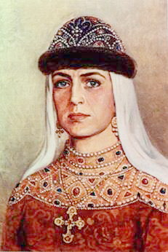
Dawn before sunrise
She was only woman among the rulers of Kyivan Rus’. Princess Olga was a loving wife, a caring mother, a wise women and an outstanding statesperson. Olga’s husband, prince Igor, was a courageous warrior. He was killed by the tribe of Derevlians, while gathering toll from them. They say that Olga was a cruel and ruthless women. She took revenge of her husband’s death having set fire to the main town of her enemies, Iskorosten’, and burnt all the residents of the town alive. But, nevertheless, Olga proved herself to be a skillful and mature ruler. After the death of Prince Igor, she ruled the country very
http://en.wikipedia.org/wiki/Olga_of_Kiev

successfully for almost 20 years and was named one of the wisest women of her time. In 945 she was baptized and did much as a Christian to her country. She built churches, invited bishops from other Christian countries and tried to rule in peace. Princess Olga died at the age of 75 and was recognized as a saint in the 12th century. She is truly called “Dawn before sunrise” for trying to spread Christianity in Rus’.
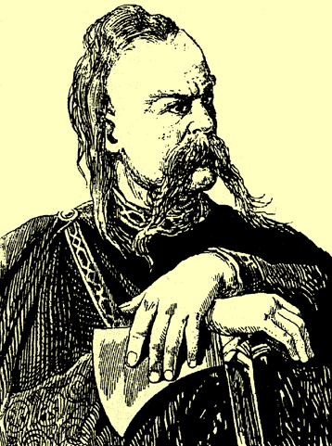
Prince of battles and swords
Being the only son of Olga and Igor, Prince Sviatoslav was a gifted and fearless warrior. He loved war. He remained a pagan in spite of his mother’s fondest hopes and warmest pleas. Every time he replied to Olga with words, “My army won’t understand me and will never accept the rules of Christian life”. For his honesty Sviatislav the Conqueror was respected both by his friends and foes. Before starting a campaign he always sent a message with a warning, “I go at You”.
http://en.wikipedia.org/wiki/Sviatoslav_I_of_Kiev
Prince and warrior, he newer took neither marquees nor cauldrons with him. He slept on ground putting the saddle under his head. Sviatoslav the Conqueror was one of those about whom people often say, “First he kisses his sword and then his wife”. He conquered Khazars near the Volga, Tmutorokan’ (a principality located where the Kuban’ flows into the Sea of Azov and the Black Sea) and Bulgarians. He besieged Constantinople and forced Greeks to pay contribution. On the way back the troops of Sviatoslav were treacherously attacked by the Peachenegs. They killed the prince in 972. According to legend, the Pechenegs made a cup out of his skull and decorated it with gold and precious stones. They believed that everyone who drank out of the cup could become as courageous as Sviatoslav was.
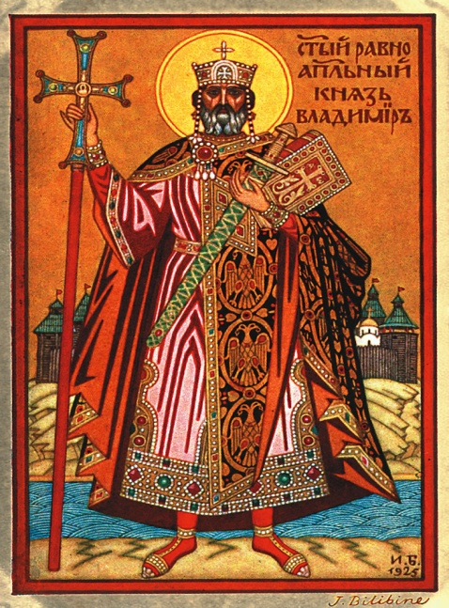
The bright sun of Christianity
http://en.wikipedia.org/wiki/Vladimir_the_Great
The plan initiated by Olga in 955 to Christianize Rus’ was fulfilled some 30 years later by Volodymyr the Great, Olga’s grandson. When she died, he was very young. Therefore, he lacked a Christian upbringing and was a pagan. However, Volodymyr was in search of another religion understanding that without spiritual unity it would be impossible to head a state like Kyivan Rus’. Influenced by internal and external political motives, Volodymyr was baptized in 987. That event was a turning point in his life and in the history of the whole country. On the 14th of August in the year 988, all inhabitants of Kyiv were baptized. The Chronicle says that the Kyivans – young and old, rich and poor, - came free-willingly and cheerfully to the Dnipro River to be baptized.
Volodymyr started building new churches and towns. He ardently inspired and encourager literacy in his state. To facilitate learning, Volodymyr established schools in towns and cities. With a broadened education base, the number of learned people in Rus’ increased markedly. These educators worked diligently to further education and promote cultural growth Volodymyr engaged renowned artists and skilled builders from Greece and Bulgaria. He beautified Kyiv , his capital city,with various forms of art. Volodymyr gave much to the poor. The fame of Volodymyr the Great-a wise and benevolent ruler-extended far and wide and reached beyond the boundaries of Rus’.He lived in peace with the neighboring countries .However, overburdened with work, Volodymyr became seriously ill and died at the age of 55.Because of his great Christian love to the needy and the suffering, his name became immortal and the chronicler called him Great.
Outstanding Achievements
OF GREAT KNIAZ The reign of Yaroslav is considered the highest point of Kyivan Rus’. After Volodymyr’s death, his eldest son killed three of his younger brothers. However, he died in battle and Yaroslav became Great Kniaz of Kyiv. When the Chronicles describe the achievements of Yaroslav,
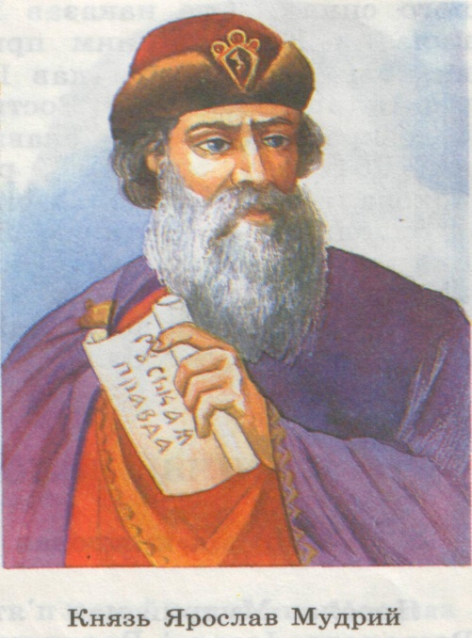
they say the field, that is he enlightened the country. And it was Yaroslav who had sown the knowledge of books into the heads of his proper. He realized that the whole population needed educators. The monasteries built by Yaroslav contributed considerably to educational enlightenment. Another factor in Prince’s educational program was the introduction of the printed word. Yaroslav himself dive the example of appreciation of the value of books. Amidst the difficult political problems, he found time, even if only at night, to read. No wonder, an ardent reader like Yaroslav
brought together many scribes who translated into the Slavonic language numerous Greek and Latin works. With Yaroslav there began the growth of culture in Rus’.
http://en.wikipedia.org/wiki/Yaroslav_the_Wise
Kyiv Rus’ achived its greatest power and splendor under Yaroslav the Wise in the 11th century. Yaroslav made Kyiv a great city and built magnificent buildings, including the notable Cathedral of Saint Sophia. During his rule Kyiv boasted over 400 churches. He also compiled the first Russian law code, the so-called «Russkaya Pravda»(Russian Justice). This important accomplishment engraved Yaroslav’s name into the history of Ukraine. Yaroslav the Wise was recognized and praised by all. He died in 1054 in the arms of his favourite son, Vsevolod. He was 75 years old. Vsevolod buried his eminent father in a white marble sarcophagus in the Cathedral of Saint Sophia.
- Brainstorming Around the World
T e a c h e r. In the year 988, the famous and great Kyivan Kniaz Volodymyr officially introduced Christianity in Rus’ – Ukraine. It was an inimitable turning point in the lives of their descendants. What were the effects of Christianity in Ukraine? ( Students’ answers are written on the board.)
Christianity
It provided Rus’ with cultural uplifting New religion helped to unite people into one nation. Rus’ become recognized in Europe. Christianity helped to enlighten people with the help of books. Many towns and cities started growing and developing . The state flourished in harmony and peace. It provided the country with a spiritual rebirth. Christianity enlightened people – to love the fatherland and to defend it, if need arises. (Etc.)
- Focus on Developing Speaking Skills
1. Teacher’s summing - up
T e a c h e r . You are quite right in defining the importance of Christianity for further development of our state. It brought into our country the guiding light of God’s Truth. It introduced a new institution – the Church. The Church unified the individual tribes, organized and consolidated them into one great powerful nation. Christianity influenced their way of thinking and contributed immensely to the development of a new culture. As examples we have literary works, education, music, architecture, religion and national politics.
2.The Twenty Questions Game
T e a c h e r. Now I’d like you to playa communicative game called “ The Twenty Questions”. One player should choose a famous person in history without mentioning his / her name. The others ought to try to guess he / she was by asking the first player questions. If you fail to guess correctly, the first player will be you some hints.
Play this game asking:
- only general questions;
- all sorts of questions.

3.Role play “ Foreigners and Kyivans’’

T e a c h e r. Now I want to divide you into two teams. One team represents foreigners to Kyivan Rus’. They have come here for the first time from Greece (Germany, France, etc.). They feel strongly surprised with everything they see in the streets, inside homes, churches and in Great Prince’s palace. What are your impressions? Brainstorm, write down some main ideas and express them to the other team. The second team is Kyivans of the 11th century. You brainstorm the answers about living in Rus’ at that period. Try to confirm your point of view.

TEAM A. You are foreigners to Kyivan Rus’. You have come from…(Greece, Germany, France, etc.) It’s your first visit to this country. Everything surprises you here. Tell your opponents about your impressions. You may ask them questions about what interests you in their way of life, religion and what not.

TEAM B. You are Kyivan dwellers. It is the 11th century. You meet the foreigners who have come to your city from...(Greece, Germany, France, etc.) They are new–comers. Try to answer all their questions. However, you should prove to be real patriots of your city and country.
Now you may change your roles.

- Personality Analysis (Writing)
T e a c h e r. I suggest that you study the faces of Kyivan rules in the pictures. Pick one of more of the faces and write an analysis of the personality, using the outline given bellow. Use your imagination freely. There are no right or wrong analysis.
After you have completed your analysis, compare them with what others have written. Then you should form groups of three or four people and discuss the different analysis.

1.Students study the faces and prepare their analysis outline
ANALYSIS OUTLINE
- Give the person a name.
- Decide what the person’s job is and describe his / her work environment.
- Describe the home environment.
- List the major personality traits, elaborating as necessary for clarity. You might want to show how home and society have influenced the personality.
2.Selecting the personalities for making up dialogues.
T e a c h e r. Well, I want you to make pairs and write a dialogue or a short story in which personality traits play a major role. For example, a sensible personality and a fearless personality discuss their acts. The wise person sees only negative aspects in participating in constant battles. The heroic and courageous person tries to explain positive aspects of his life, full of danger and risk.
- Debate
T e a c h e r. We’ve spoken about our history and those events which took plays more than a millennium ago. However, “History never stops. It progresses ceaselessly day and night. And trying to stop it is like trying to stop Geography”, said Augusto Monterroso, a famous Mexican writer (Augusto Monterroso (1921 - ?) Guatemalan-born Mexican writer. “The Rest is Silence”, “Aforismos, dichos, etc.”) These words are especially precise when we ponder on the recent revolutionary events which happened in our country at the end of 2004. All of us have great expectations for the future. And the personality of President defines the future we are going to have. So bearing the figures of the past in mind, let’s discuss what politics is. Try to define it. (Students answer the question offering their own definitions of the word. The teacher makes notes on the board.)
1.Teacher’s questions
- Would you like to be a politician? If so, what office would you like to hold?
- Would you like to be President? What first steps would you make holding this position?
- What makes a good politician / President?
- Politics has existed since the first pyramids were erected in Egypt. Is politics necessary in any system of government? Try to explain your answer.
- What influences voters the most: appeal to emotions or appeal to reason?
2.Organizing a debate
Teacher. We are going to choose two or three current political issues in Ukraine and debate them in class. Now form two debates and designate winners.
(Students participate in the debates. The judges select the winners.)
- Summarizing ( Homework)
Teacher. I believe all of us are looking forward to our future. Because as one German politician said, “A people not prepared to face its own history cannot manage to face his own future”. (Attributed to Karl-Heinz Hansen, German politician).
For your homework, I offer you to choose one or more personality from modern politics and prepare a personality chart following the outline below.
Personality chart
Physical Appearance/ Background/ History/ Basic Attitudes/ Beliefs

